# 

# 

# 

**Sentiment Analysis on McDonald’s**

Group 6:

Customer Sentiment

Team Members:

Nanda Rajaraman, Ezra Degafe, Humberto Alvira

Course: CIS 4720

Instructor: Dr. Xue Guo

**Introduction**

In today’s fast-food market, aligning products with consumer expectations is essential for a company’s success. McDonald’s has faced backlash over the last few years regarding customer dissatisfaction over various aspects of their business. As consumers seek greater value for their money, understanding public sentiment is important for McDonald's to apply reasonable measures to combat negative experiences.

This report aims to offer recommendations based on sentiment analysis and topic modeling using customer review data to assess consumer perceptions of the McDonald’s brand. The insights gained will aid McDonald's to make data-driven decisions to address market concerns and strengthen its brand image.

**Dataset Overview**

The dataset in this sentiment analysis project is from Kaggle and has 33,396 customer reviews across several McDonald’s store locations. The dataset is made up of both structured and unstructured data thus offering quality context for text mining and sentiment analysis. While the dataset offers some key features such as customer ratings, store name & address, review time, and business category type, the analysis in this project only uses the unstructured review text field.

The customer reviews offer a dense source for extracting sentiment without relying on numerical ratings. The goal of this project was aimed towards capturing the true opinion of the customer outlining what aspects of their experience were positive or negative. This approach enables a deeper understanding of the specific themes shown in customer feedback which helps to identify actionable insights directly from the customer’s response and to develop recommendations to combat negative customer experiences.

**Data Visualization & Insights**

To develop actionable insights from the customer review text, a sentiment analysis was carried out and visualized through two plots:

The first visualization, **Top Words by Sentiment**, shows the 7 most commonly occurring words across 10 topics. The negative sentiment included common words such as “slow”, “wait”, “rude”, “waiting”, and “dirty” which were good indicators of issues primarily around slow service, long waits, staff issues, store cleanliness, and parking lot/drive thru congestion. This can be seen through the words described in topics 2, 4, 7, and 9. The positive sentiment included common words such as “friendly”, “hot”, “nice”, “clean”, “fast”, and “fresh” which indicates that speed, food quality, and customer service are key contributors to a positive dining experience. These positive terms can be seen throughout the rest of the topics excluding 2,4,7 and 9. Overall, the filtering of these words helped to identify key drivers of customer satisfaction and dissatisfaction. The plot below displays the top seven words across ten topics.

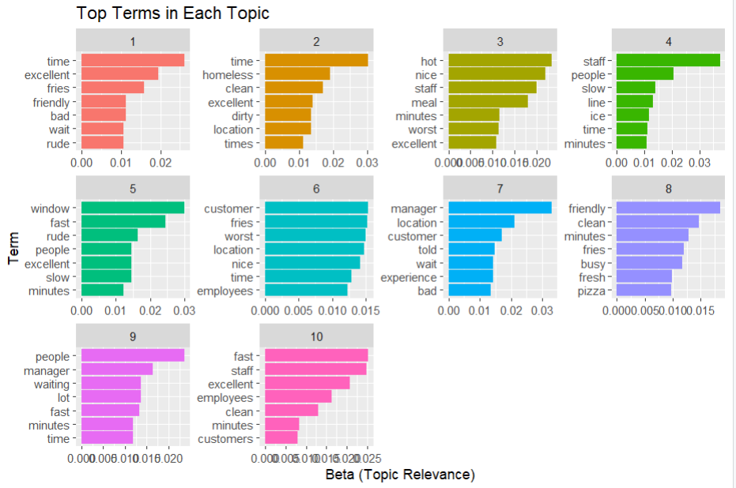

The second visualization, **Sentiment Distribution by Topic**, categorizes sentiment based on the count of negative vs positive sentiment per the topics generated. Based on the visualization, there was an overall positive sentiment around the McDonald’s brand mostly seen in topics 3, 8, and especially 10. Even though positive sentiment outnumbered the negative sentiment, there are still topics with a considerable amount of negative sentiment primarily in Topic 2, 4, 7 and 9. Some topics do make it very clear of the negative terms carrying the topic, but some were mixed such as topic 9.

These insights provide McDonald’s with context on the general sentiment overview based on google reviews but also displays the considerable amount of negative sentiment still present. Based on the graph below, there are topics where negative sentiment is almost equal in number to the positive sentiment.

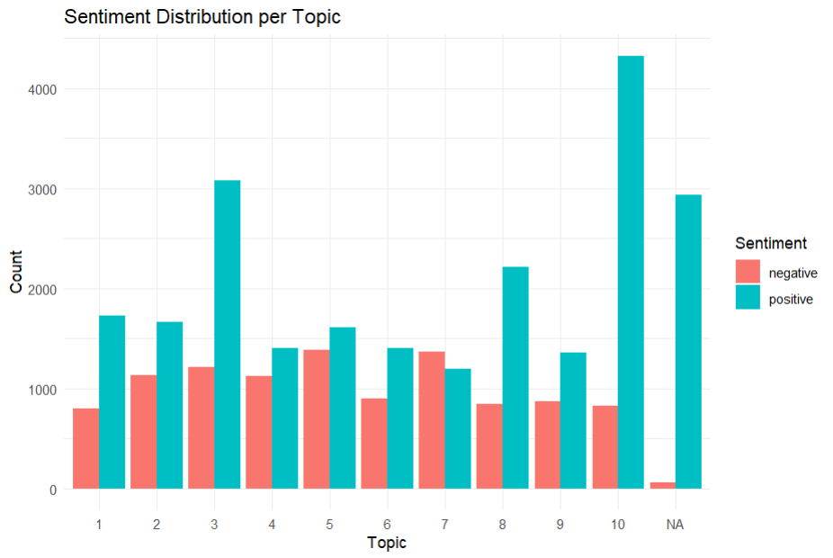

### **Storage and Recommendations**

To manage structured data such as customer ratings, store locations, and review timestamps, we recommend that McDonald’s use an SQL database. SQL databases allow for quick and productive querying and aggregation, making it easier to analyze structural data such as prices, ratings, and dates across multiple locations. In contrast, handling unstructured data such as customer review text would benefit from a NoSQL database like MongoDB. NoSQL solutions provide flexibility to store lengthy entries as it is needed to perform sentiment analysis on large customer bases like McDonalds.

An efficient way to store the structured and unstructured data jointly would be through a data lake. A data lake environment would enable easy integration and analysis of information from different McDonald’s branches, allowing for greater scalability and insights taking into account multiple store locations.

For the processing of review text data, McDonald’s should apply Natural Language Processing techniques such as sentiment analysis and topic modeling. These methods can help find specific issues that negatively affect customer experiences, including long wait times, bad interactions with staff/managers, and cleanliness concerns. To be more effective it is recommended to implement a real time data processing model to analyze review text data to further enhance the speed in which negative experiences are addressed.

The proposed solution closely aligns with McDonald’s mission to improve customer satisfaction and protect its brand’s outlook. By applying sentiment analysis and topic modeling to customer reviews, the team was able to extract operational inefficiencies that are very important to address. Negative sentiment was found to be primarily driven by problems such as long wait times, bad staff behavior, and food safety and cleanliness. On the other hand, positive sentiment was largely associated with quick/easy food service and friendly employees.

Based on these findings, we have several actions that are recommended to strengthen McDonald’s operations and customer experience. First, a sort of customer service training should be administered to stores that consistently get negative feedback from customers. These programs would focus on improving staff behavior towards customers, enhancing service speed, and teaching overall professionalism. In addition, it is recommended that McDonald’s implement a real-time customer feedback system through its app. This system would enable customers to report issues hassle-free and receive fast responses or things such as coupons or free items as an apology from the store.

McDonalds should take the proactive steps to engage customers and resolve complaints in real time is likely to increase trust in the McDonald’s brand. Customers who feel valued and heard are more inclined to remain loyal and share positive experiences with friends and family. Over time, such changes could lead to increased customer retention, stronger brand perception, and overall greater long-term revenue growth for McDonald’s.